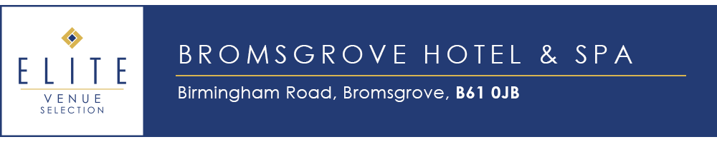
Did you know we have conference rooms?

We have the Elgar Suite which can accommodate 225 delegates in theatre style and 150 delegates in Cabaret. It has access to private toilets and a private bar area for those all-important breaks. We can even accommodate for smaller conferences in Marlbrook and Wildmoor.

Our Day Delegates packages include:
X3 servings of Tea/coffee and biscuits
Buffet Lunch - We can cater to your delegates dietary requirements
Equipment hire such as projectors, LCD screen, flip charts, pads and pens
Bottled water on the tables

Use code Bromsgrove to get bacon rolls included in your arrival with Tea/Coffee refreshments. Alternatively, you can have baked cookies with your afternoon refreshment break.
Please contact Holly Taylor for a show round of our facilities or to get a quotation for your conference/Event:
conf757@theelitevenueselection.co.uk
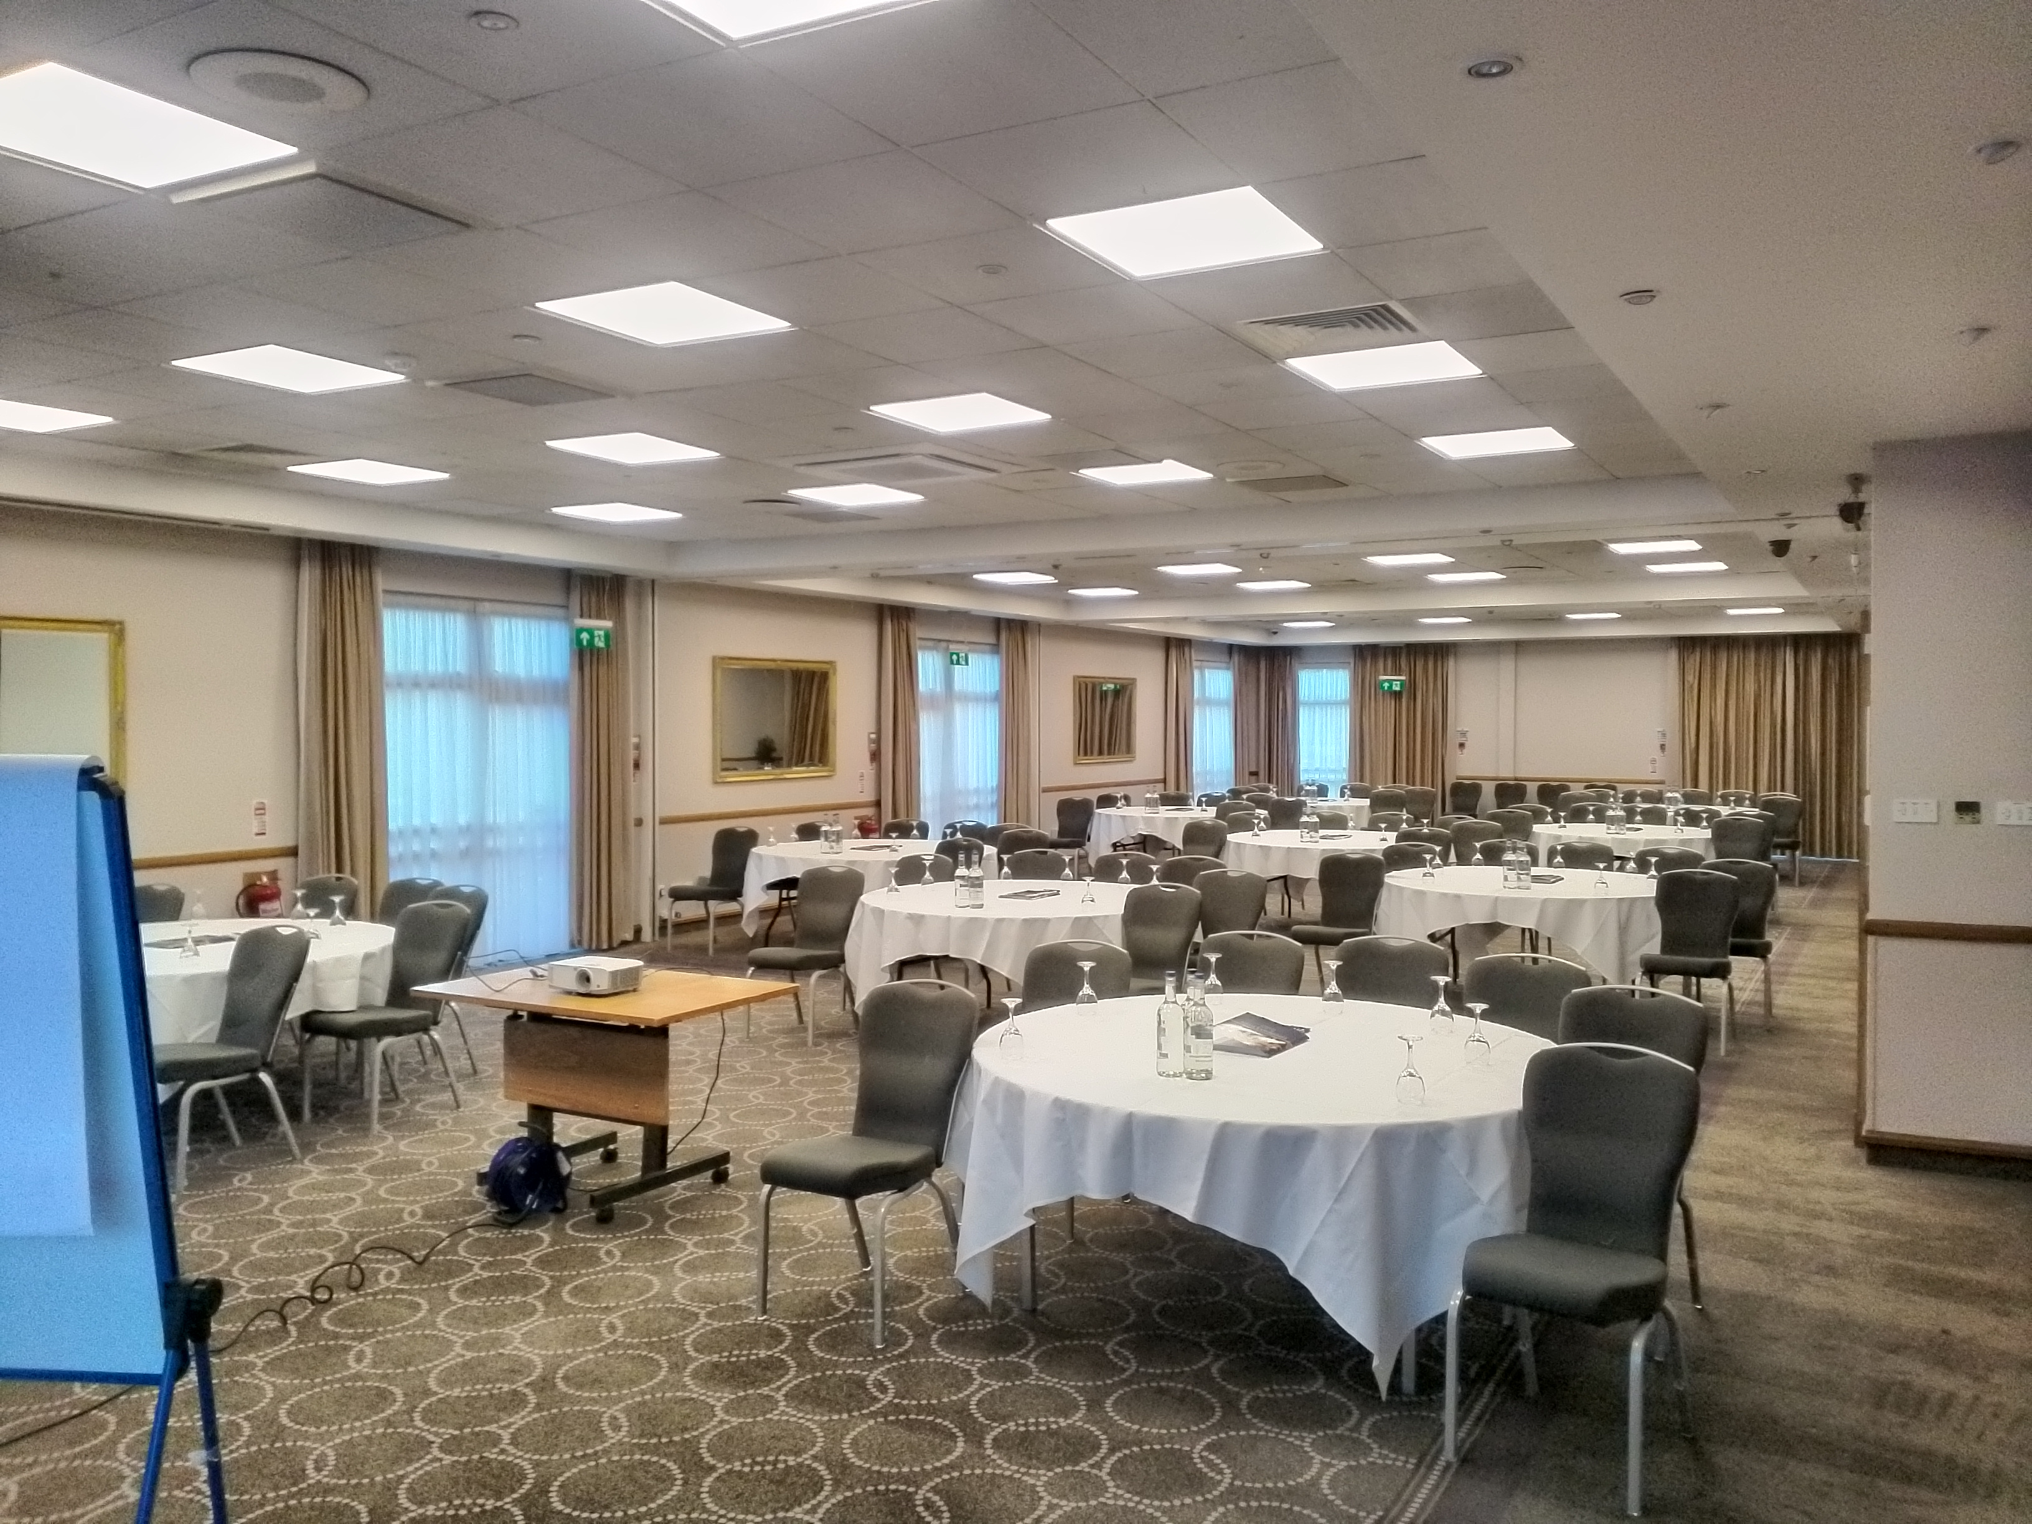
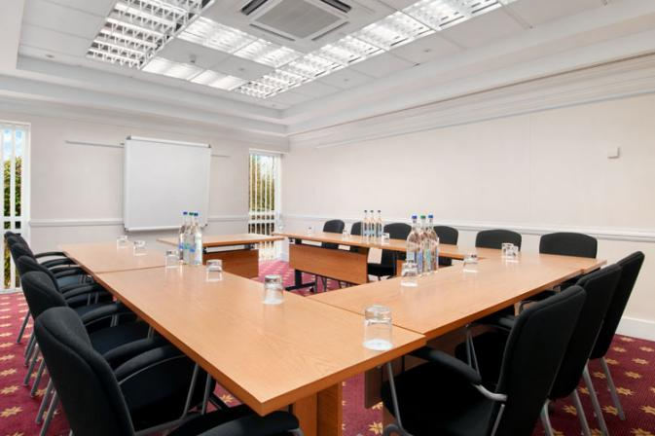
0121 447 4538

